**Team Zoo GuideMeeting Minutes**

**Date: 1/29/2021**

Attendees: Rebecca Grantland, Sarah Wathke, Suzanne Moore, Zachary Jones, Hritik Pathak, Christopher Cotten

Items Discussed and Decisions Made:

* notes rotation - In order of who joined the group, there will be a rotation starting with first going to last then repeat. These notes will be shared with the group after the meeting.
* when to meet - We will meet as a group Friday's at 4pm for 1-2 hours
* who took 414 with Professor Elliott/has reviewed the materials in Canvas o Me Zach and Sarah did not take 414 from Professor Elliott, but have/will review the materials she has posted in Canvas.
* version of app suggested - create a visual interactive map that when a region is selected, it will display a menu of animals in that location
  + 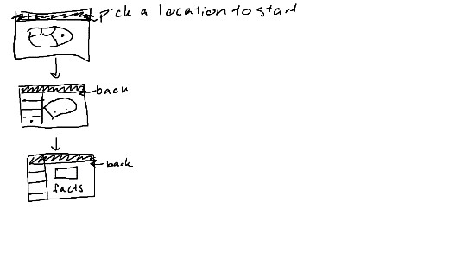<- illustration of proposed map interface
* what to base our zoo off of o The map and animals will be based off the Hattiesburg Zoo.
* languages o HTML CSS PY SQL
* tools o Proposed compilers and text editors were EclipseIDE, Visual Studio, and Atom.
* interests/strengths/probable roles o I will work on back end in Python
  + Suzanne and Sarah willing to work on front end and have done some research o Zach has some experience in HTML and willing to gather info and photos from

Hattiesburg Zoo.

PowerPoint to come later in project o The possibility of having to create State Diagrams and Flow Charts based on code was discussed. Examples of both were shown to the group to make sure everyone was familiar with what they were, and that more information could be found in CSC414 files on Canvas. o Decided that google slides would be used to create the PowerPoint, and slides would be divided between team members if possible.

Action Items:

* Christopher, Sarah, and Suzanne are to research more on front end development in HTML and CSS.
* Hritik is to research more on working on back end in Python.
* Zach is to gather info on the Hattiesburg Zoo, namely a list of regions and animals in the zoo. He is also to assist in research for interactive maps to be used in front end development.
* Rebecca is to compile a list of required facts to be listed for each animal, begin listing requirements for documentation, research back end in Python (namely integration of SQL database with Python), and refresh on SQL databases.